**CTF Topic: Discovering Patterns with Finding Patterns Chrome Extension**



**1. Introduction**

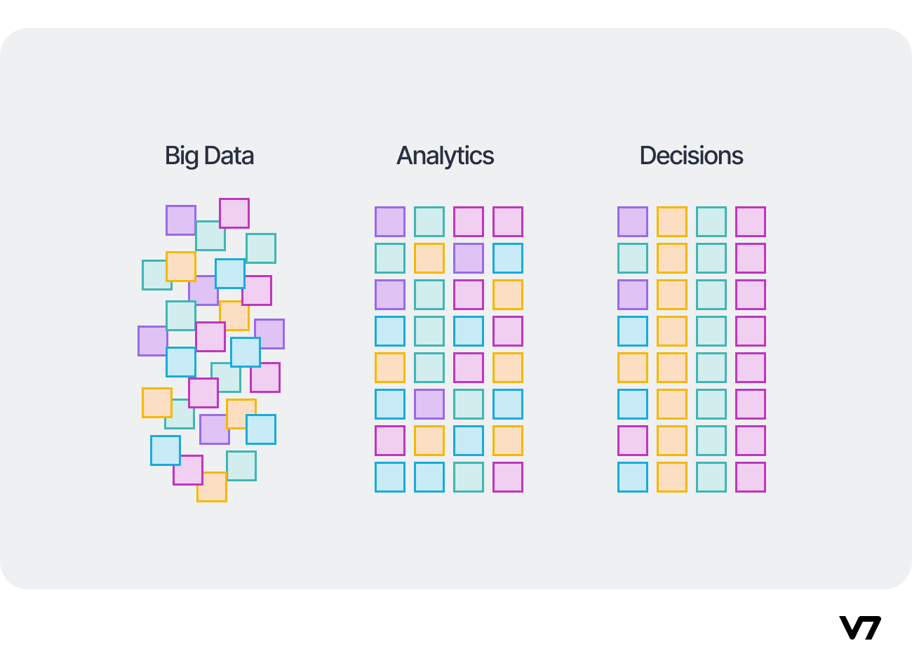

The "Finding Patterns" Chrome extension assists users in detecting and extracting specific patterns from web pages. It enables the identification of structured data or hidden information that follows consistent formats, aiding in data extraction and analysis.

**2. Tools and Requirements**

Google Chrome browser Install the [Finding Patterns Chrome extension]

**3. Scenario**

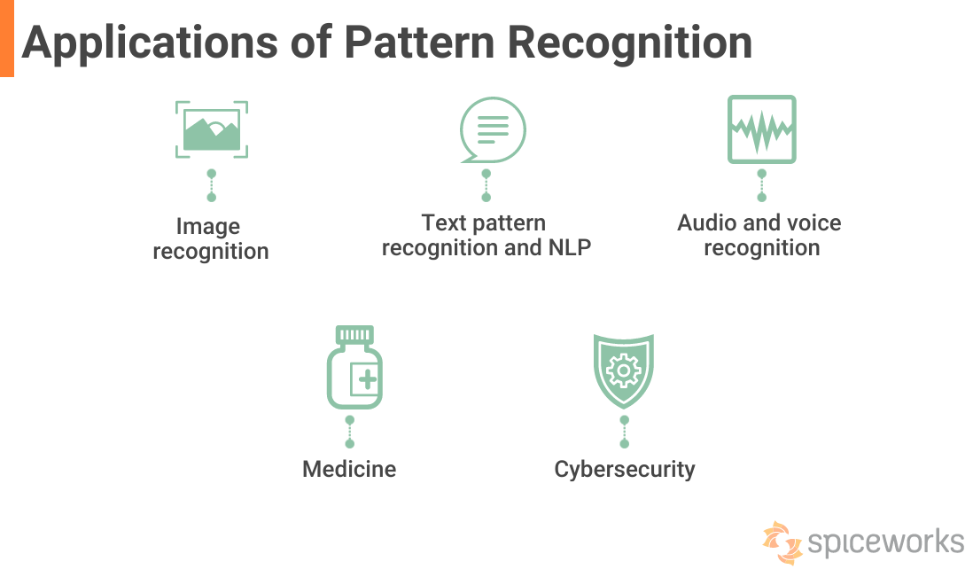

As a participant in this CTF challenge, your task is to use the Finding Patterns Chrome extension to identify specific patterns and extract meaningful data from `http://testphp.vulnweb.com/`. Perform the analysis and answer the following questions based on your findings.

**4. Process to Follow while performing CTF**

**Step 1:** Install the Finding Patterns Chrome extension from the provided link: **(**[**https://chromewebstore.google.com/detail/finding-patterns/fikfnienebmgobclladdionkabigeico**](https://chromewebstore.google.com/detail/finding-patterns/fikfnienebmgobclladdionkabigeico)**)**  
**Step 2:** Visit **`**[**http://testphp.vulnweb.com/**](http://testphp.vulnweb.com/)**`** and use the extension to detect and analyze patterns on different pages.  
**Step 3:** Use pattern detection and solve the CTF

**Questions and Answers**

Flag 1: Use the Finding Patterns extension to detect a pattern in the product listing on `http://testphp.vulnweb.com/listproducts.php`. What is the pattern identified?

Answer:  
Pattern: Product Name, Price

Flag Captured.

Flag 2 : Use the Finding Patterns extension to extract the names of all products listed on `http://testphp.vulnweb.com/listproducts.php`. List two product names.

Answer:  
Product 1: Flamethrower  
Product 2: Toaster

Flag Captured.

**Hint**

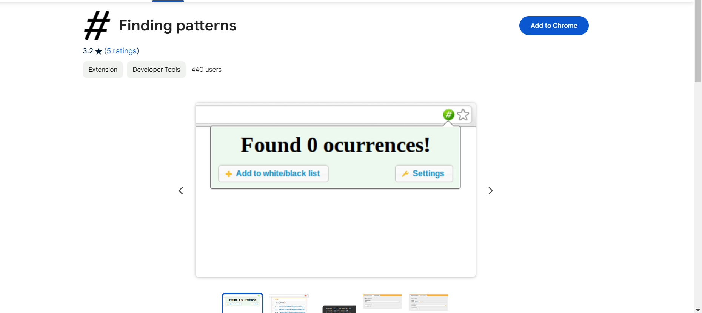

Install the Finding Patterns Chrome extension and explore different pages of `http://testphp.vulnweb.com/` to identify and extract patterns. Pay attention to consistent formats, such as product listings, URLs, form fields, and other structured data, to answer the questions accurately.